# Creative Coding Assignment 2

For this assignment we were tasked with creating an interactive kinetic typography animation. For this assignment I decided to attempt to create interactive text using the seek function. The aim of my assignment was to create a piece of text, made out of agent points. Once these points were made, the next thing to do was to make the agents move in a frantic way, and eventually have them return back to their original location.

First thing to do was to add text to a canvas, with the text I loaded in my chosen font, which was FreeSans. Once this was done, all I needed to do was change text colour, size etc.



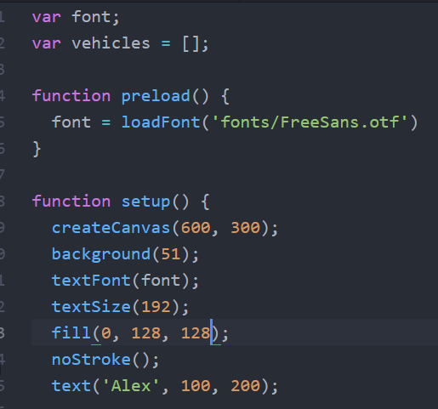

After loading text onto the canvas, next was to create some agents, which I called vehicles. They would then recreate the text, but in point form, this is done by checking for each point in each letter of the text. The stroke and strokeWeight can be manipulated in here

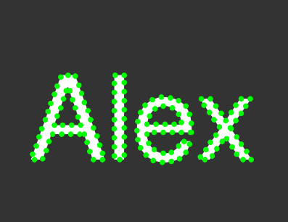

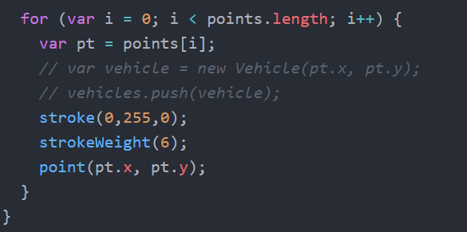

Once that was done, next was to remove the function that writes the text, and only have the agents recreating the text using points. This was done by simply removing the textFont, textSize, fill and the text itself, along with the placement.

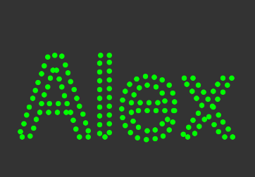

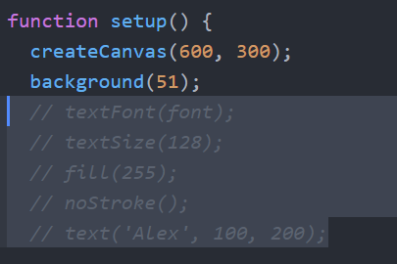

Next thing to do was turn the points into particles, that would move around the screen, I started off by starting them off in a random position. The particles are created in a constructor which is called Vehicles. As these particles need a position, we give them a Vector, in position, velocity and acceleration, as well as a target. We give it a starting x & y position and target position

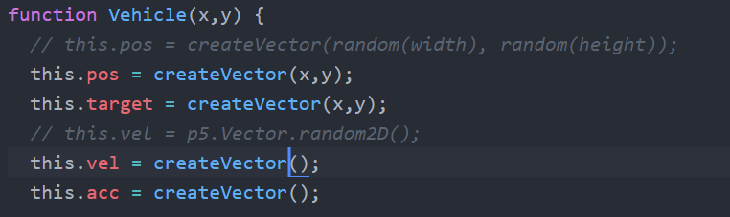

Next was to add physics to it, this was done by creating a vehicle prototype for the update and display

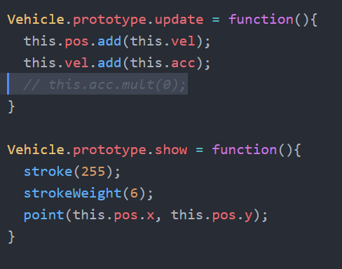

The vehicles are called in the sketch in an empty array, for every point in the text a new vehicle is called

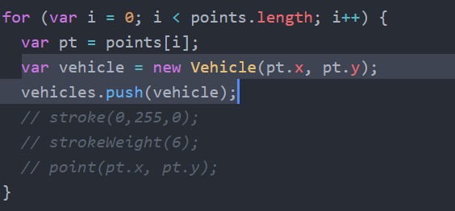

In the draw function, it retrieves the information from the vehicle constructor, and allows the agents to update and show

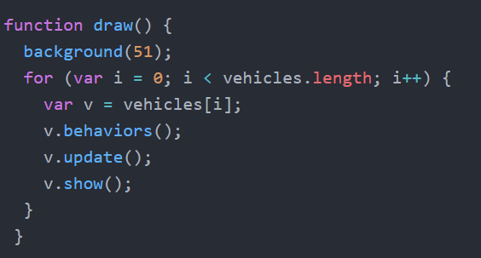

Each vehicle is to calculate vector from itself to the target, and scale it at its desired speed

We set the vehicles maxspeed, so it would constantly be its desired speed.

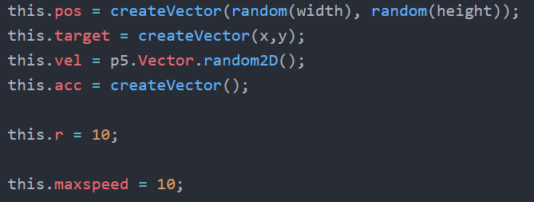

The final thing to do was to allow the mouse to interact with points and make them disperse when interacted

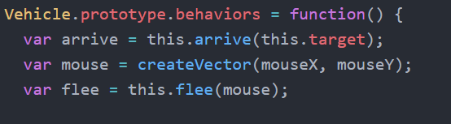

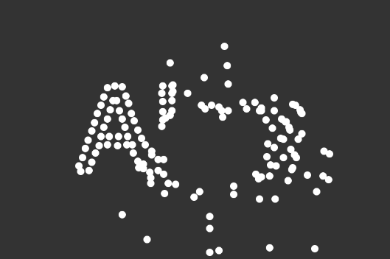

After trying and failing to introduce a GUI,I decided to add a simple slider which would change the background colour of the canvas. After this, I decided to change the code up a bit, stick with interactive particles but introduce a text change. I decided to allow the user to click the screen and the words on the screen would appear.

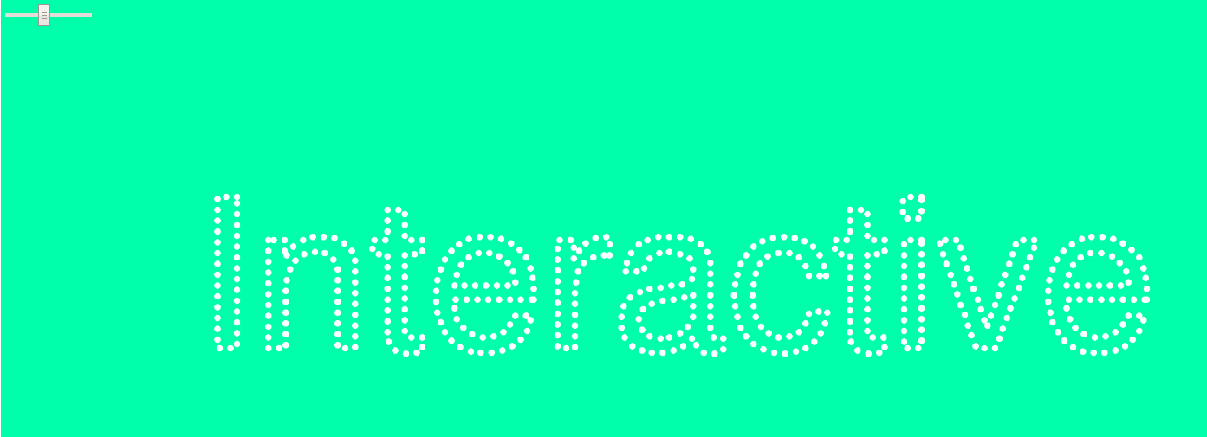

I added a text array, that contained the words that will appear on the screen, along with instruction empty array, with the text ‘Click to change text’

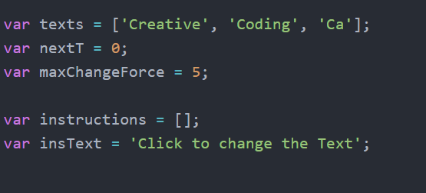

I added a textBound function. Which is a p5 function that returns a tight bounding box for the given text string. As well as its x and y position

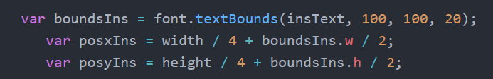

In order to create new longer words, the particles needed to be spliced

